Download software

1.JDK 11

2.Maven

3.GIT

4.Aem Jar

5.Eclipse or any IDE

**JDK setup environmental Path**

Add New provide JAVA_home and specify the path

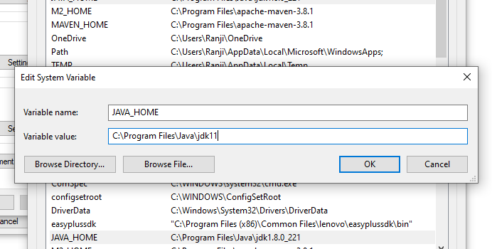

Select Path and provide path \bin

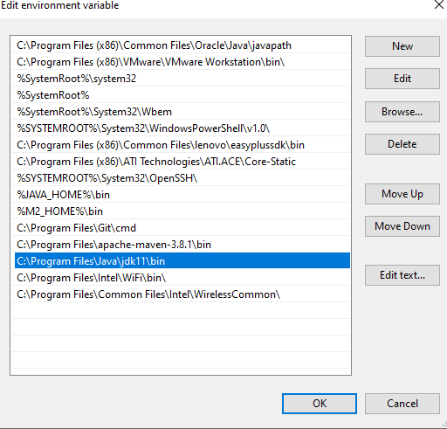

**MAVEN**

**Step 1:** Unzip the file on file system on drive, and Set below 2 envionment variables

M2_HOME and MAVEN_HOME

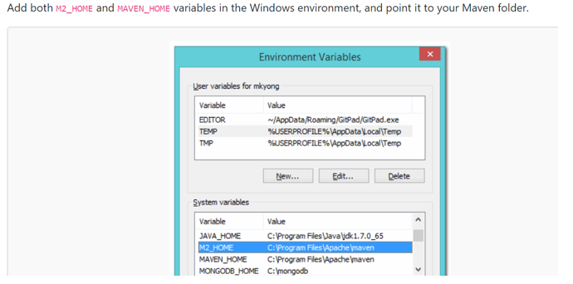

**Step 3:** Update the path variable

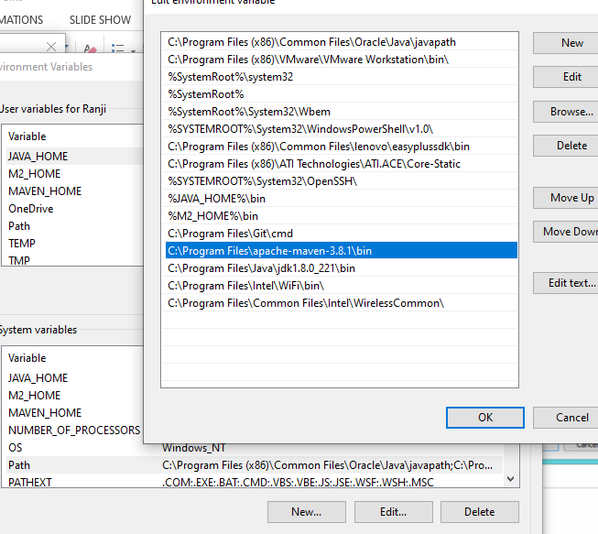

Install git and eclipse